question-1

use Database_Submissions;

create table code_employee(
empno int primary key,
empname varchar(35) not null,
empsal numeric(10,2) check (empsal >= 25000),
emptype char(1) check (emptype in ('F', 'P')))

create or alter procedure Add_Employee
@emponame varchar(35),
@emposal numeric(10,2),
@empotype char(1)
as
begin
declare @empno int;
select @empno= isnull (max(empno),0)+1 from code_employee;

insert into Code_Employee(empno, empname, empsal, emptype)
values(@empno, @emponame, @emposal, @empotype);
end

select * from code_employee

insert into code_employee values(2,'Monu',40000,'P')

insert into code_employee values(3,'Sheetal',50000,'F')

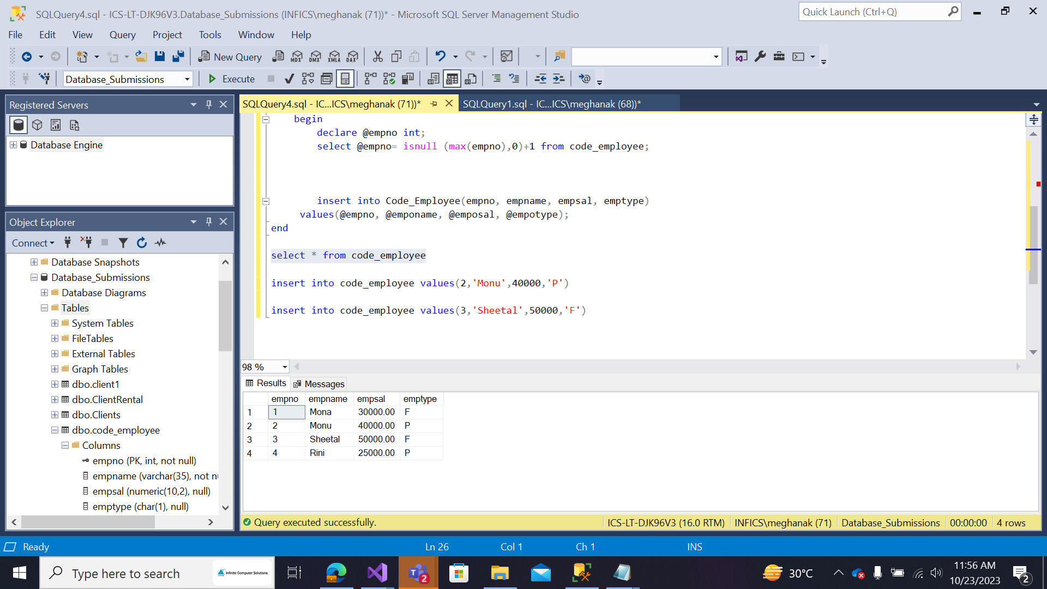

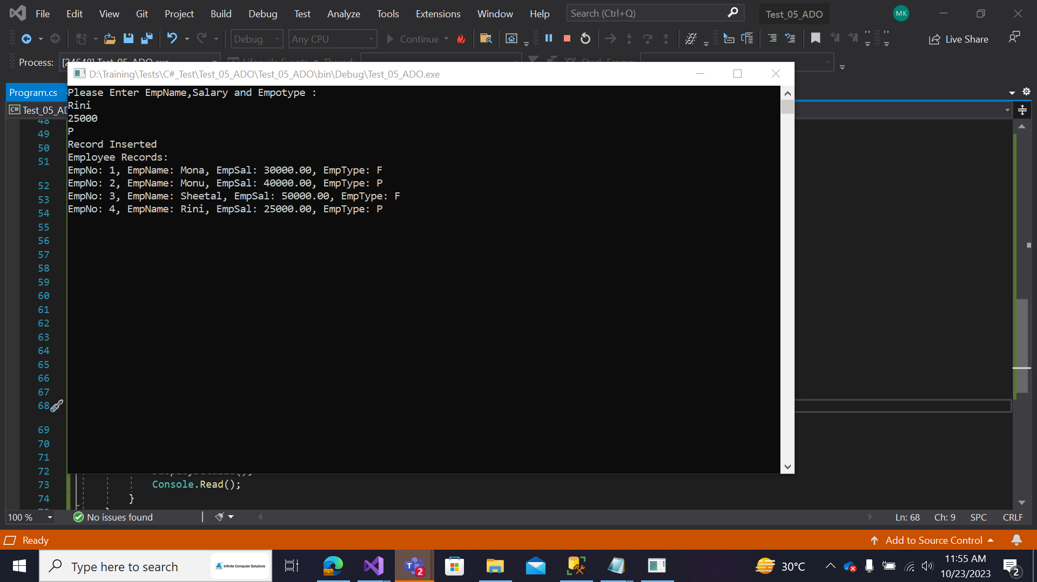
question-2
use Database_Submissions;

select * from Emp
Select * from DEPT

--creating a cursor
declare employeecursor cursor for
select empno, salary
from emp
where deptno = 10
declare @employeeno int, @salary int
open employeecursor
fetch next from employeecursor into @employeeno, @salary
while @@fetch_status = 0
begin
set @salary = @salary * 1.15
update emp
set salary = @salary
where empno = @employeeno
fetch next from employeecursor into @employeeno, @salary;
end
close employeecursor
deallocate employeecursor
//before values of emp 7782 is 2450, emp7839 is 5000, emp7934 is 1300

